**Name: Aqsa Khurram**

**SAP ID: 50086**

**LAB TASK**

**TASK-01**

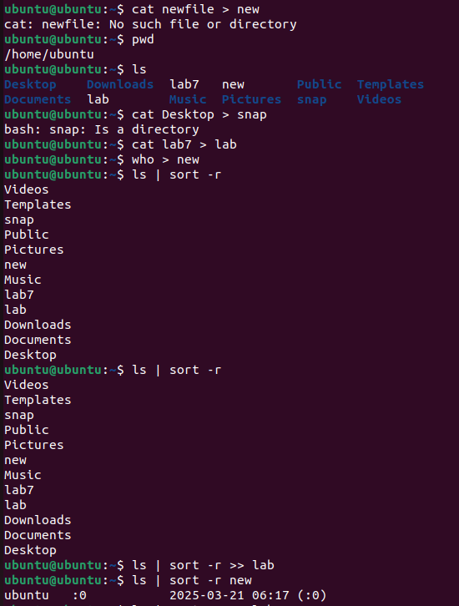

**TASK -02**

**Explanation:**

1. sort fruits.txt: This command sorts the contents of fruits.txt in alphabetical order.
2. |: The pipe (|) takes the output of the sort command and passes it as input to the next command.
3. grep "ap": This filters the sorted output, displaying only the lines that contain the substring "ap".

**TASK-03**

**Streams:**

**Definition**: Channels for data flow in and out of a program.

* **stdin**: Input (e.g., keyboard).
* **stdout**: Output (e.g., terminal).
* **stderr**: Error messages.

**Example**:

echo "Hello" # Outputs to stdout (terminal).

**Redirection:**

**Definition**: Redirects input or output to/from files instead of the terminal.

* >: Overwrite file with output.
* >>: Append output to a file.
* <: Input from a file.

**Example**:

echo "Hello" > file.txt # Writes output to file.txt.

**Pipes:**

**Definition**: Passes output of one command as input to another.

* |: Connects commands.

**Example**:

cat file.txt | grep "apple" # Filters content from file.txt for "apple".